JAVA STUDENT MANGEMENT

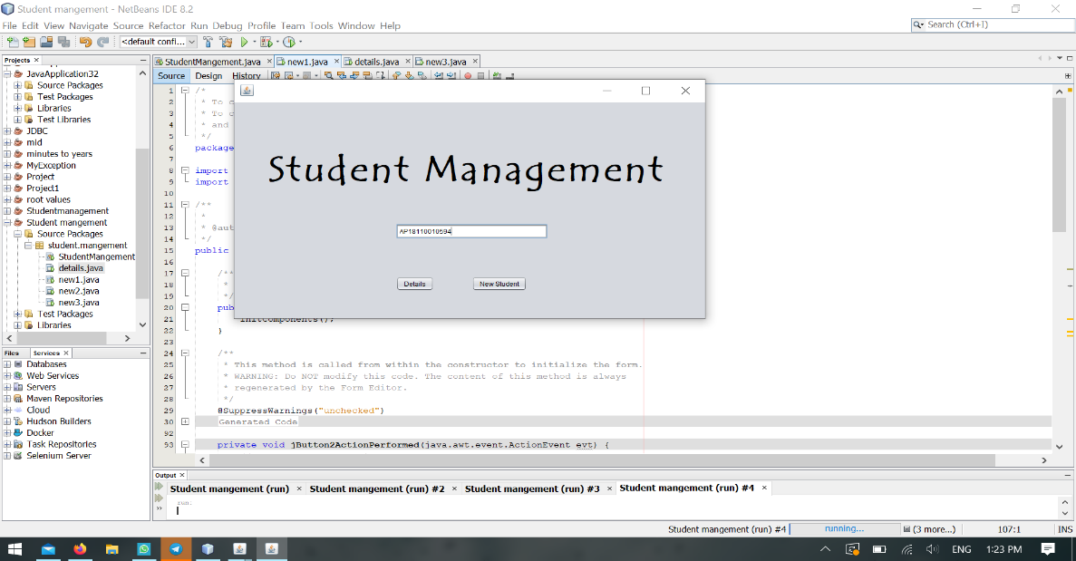To display student information:-

* This is frame1 contains a string message of student register number.
* 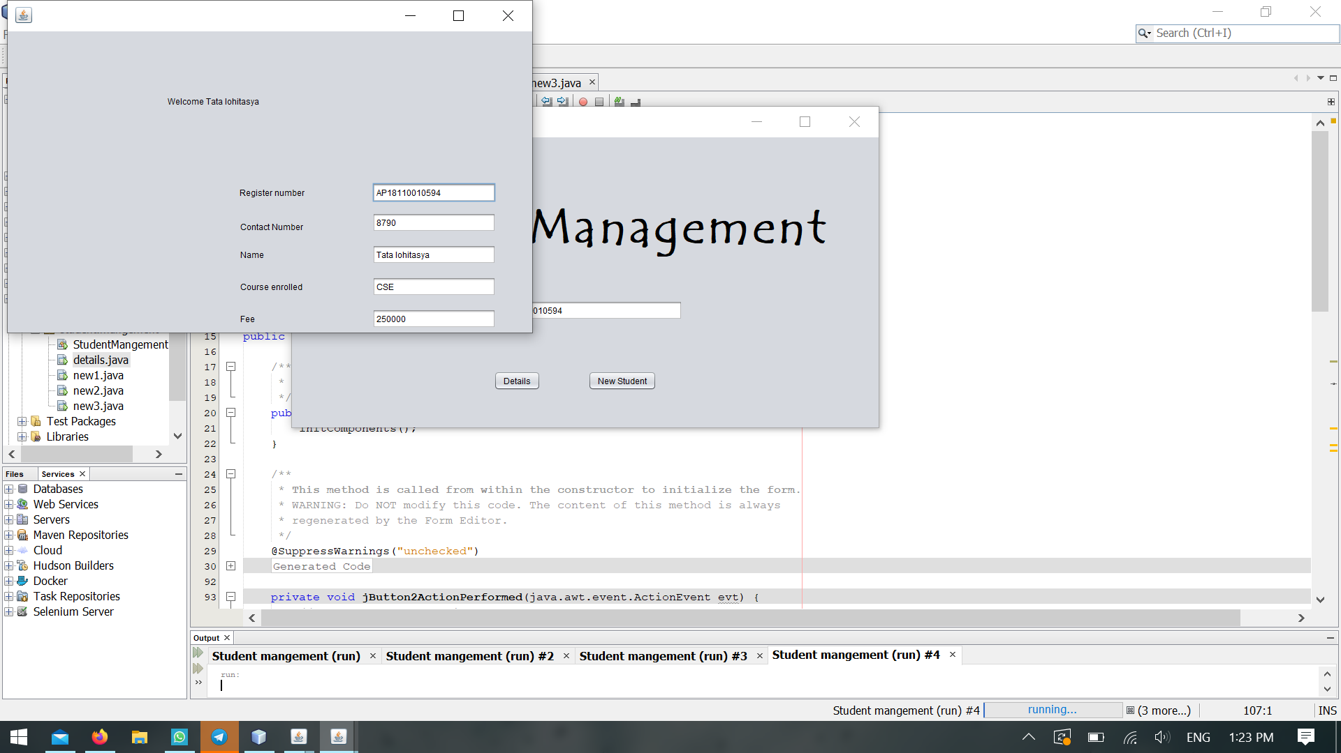When Details button is clicked the information is displayed.

To store details of student :-

* When new student button is clicked the it access the frame3 to store the student information.

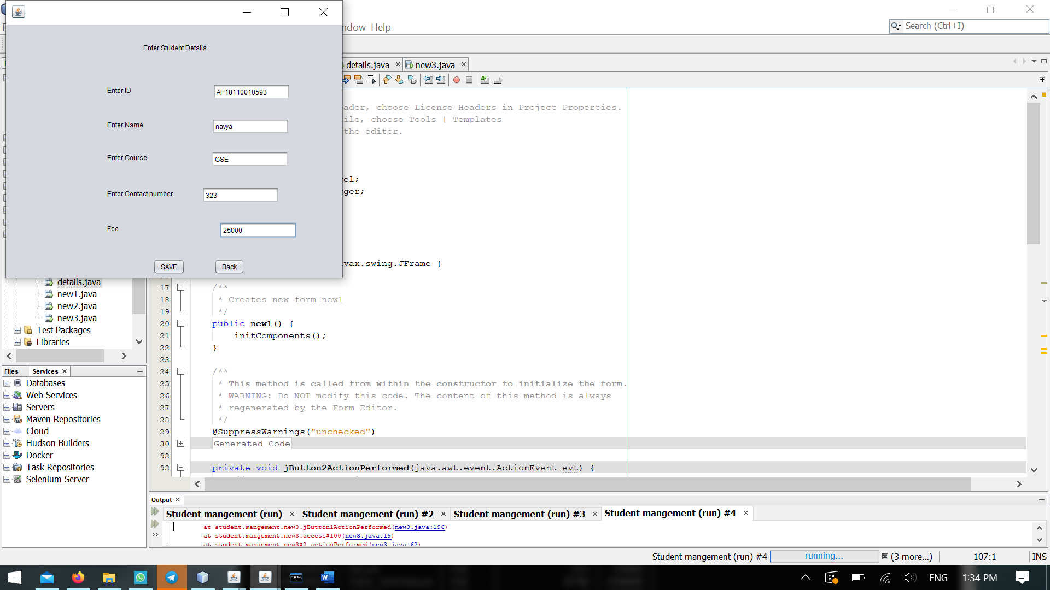

* We can check the information through the mySQL command line.

